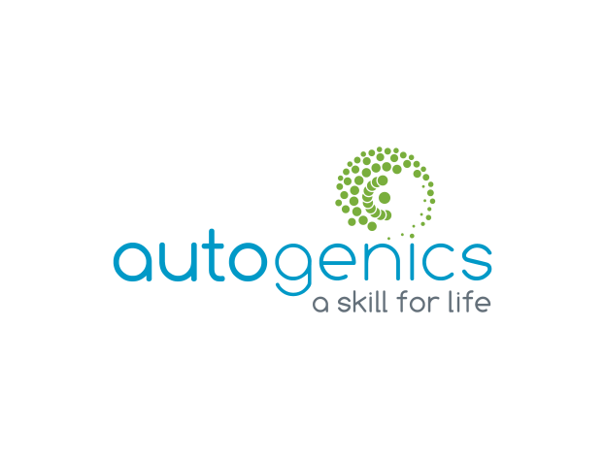
autogenic therapy and training institute
A.B.N. 13 506 189 781
Exclusive offer to
APS members

PROFESSIONAL TRAINING COURSE IN AUTOGENIC THERAPY
67t589

 | e: | info@autogenics.com.au
 | w:  ph: | www.autogenics.com.au  0416 102 190

Diploma in Autogenic Therapy (for Registered Health and Allied-Health Professionals)
- The Autogenic Therapy and Training Institute is the only internationally and nationally accredited provider of professional training courses for Autogenic Therapists/Trainers in Australia.  - Designated an evidence-based Focussed Psychological Strategy by Australian Psych Society. |  |  | - Accredited by ICAT (the International Committee for the Co-ordination of Clinical Applications and Teaching of Autogenic Therapy, Lyon France), AAS (Australian Autogenic Society) and ISATAP (International Society of Autogenic Training and Psychotherapy, Madrid, Spain).  - Qualifies for CPD.
Who is this for:
The Diploma in Autogenic Therapy is for Registered Health and Allied Health Professionals wanting to practice as Autogenic Therapists. Graduates of the Diploma of Autogenic Therapy can register as Professional Members of the Australian Autogenic Society (AAS). Professional Membership of the AAS qualifies members for registration with the International Society of Autogenic Training and Psychotherapy (ISATAP). Membership with AAS welcomes attendance of Professional Members at the yearly ISATAP Conference (usually held in Europe) and encourages Members to make a scientific contribution to the promotion of AT worldwide by presenting an original research paper.
Course Objective:
This Diploma course leads to the professional qualification of Autogenic Therapist. Unlike most therapies, with Autogenics it is compulsory for trainee therapists to attain self-autonomy/mastery of the Autogenic Methods before learning how to apply it as a therapist. This assures the highest level of professional competency upon graduation as an Autogenic Therapist. As a result, at the completion of the Diploma course our graduates will have the competency to apply the Autogenic Methods for both personal and professional purposes.
Course Content
The history, background, theory, science and applications of Autogenics
- history of AT, applications, research  - Autogenic Therapy and Training: a global perspective  - the science of AT: neuro-psychological, biochemical, physiological and epigenetic dynamics (cognitive, emotional, behavioural and physical)  - understanding the differences and similarities between Autogenics, Eastern forms of Meditation, Mindfulness, Hypnotherapy and Biofeedback Training |  |  | - self-regulation and homeostasis  - prevention and treatment vs self-development and a spiritual process towards a sense of ‘oneness’ and self-actualisation  - the role of autobiographical memories and Biomemories© in psychological and physical healing and self-actualisation while in the Autogenic State
The practical, step by step Autogenic Process
- hands-on, prescriptive, methodical experiential learning/self-practice of the Autogenic mental exercises (internalising and practising what we preach)  - how to consciously control the Autonomic Nervous System and switch on self-healing and self-actualisation through self-regulation and homeostasis  - Autogenic postures and environmental considerations  - training protocols  - stages and phases of the Autogenic Process  - ‘amplified’ and ‘altered’ states of consciousness during AT  - the Autogenic Switch  - the Autogenic State  - training symptoms vs Autogenic Discharges  - Autogenic Meditation and dual concentration |  |  | - passive concentration, passive awareness and passive acceptance  - interoceptive and proprioceptive awareness  - how to deal with anxious resistance  - The Preliminary/Priming Exercise (Body Scan)  - measuring and monitoring before and after formula effects  - The 6 Standard Formulae or Exercises  - The Supportive Formula  - The Jaw, Neck and Shoulders Exercise  - The Close/Cancellation Technique  - The Personal and Motivational Formulae  - The Physical Healing Formulae  - The Autogenic Bio-memory Formula © (Gibbons, J; 2015)  - The Short Exercises
Clinical applications and considerations: the therapeutic and peak performance context
- Autogenics as a Psychotherapy  - indications and contra-indications  - structuring the sessions including assessment, diagnosis, when and if to refer on, pacing the training, applying an individual approach to suit client needs  - applying Autogenic Therapy for the prevention and treatment of psychosomatic and other medical conditions such as chronic pain, migraine, gastro-intestinal disorders, psoriasis, Glaucoma, cardio-vascular disease etc.  - applying Autogenic Therapy for the prevention and treatment of phobias, OCD and other Anxiety Disorders, PTSD, ADHD and Depression and other mental conditions  - applying Autogenic Therapy to assist with insomnia, fatigue, concentration, memory, problem solving and decision making |  |  | - applying Autogenic Training for increased creativity, motivation and peak performance in sports, performing arts, academic pursuits, public speaking etc  - applying Autogenic Biomemory Therapy for all applications  - applying Autogenic Therapy and Training in the workplace for Occupational Health, Safety and Performance using a case study examining the implementation of Autogenic Programmes by the Autogenic Therapy and Training Institute with NSW Police  - harnessing the power of the placebo response via the Autogenic route  - teaching Autogenics in groups
Course Details
Course Location |  |  | Course Duration
Sydney CBD or nearby (TBA) |  |  | October 14th, 2017 to March 24th, 2018
Course Dates (each session is held on Saturdays from 9:00am until 12:00pm)
Term 1 (2017): October 14th & 21st |  | Term 2 (2018): February 10th & 24th
November 4th & 18th |  | March 10th & 24th
December 2nd & 16th
Course Registration
To apply send cover letter and short resume, one professional and one character reference and receipt of payment via bank transfer to h.gibbons@autogenics.com.au by no later than Saturday October 31st. Please note that places are strictly limited and not secure until full payment received. Should the course not go ahead due to insufficient enrolments, applicants will receive a full refund.
Course Fee |  |  | Payment Details
$4,950 (includes between-term email support)  Exclusive offer to APS members:  20% off $3,960 |  |  | - Account Name: Helen Gibbons  - Bank: NAB  - BSB: 082 080  - Account Number: 48 371 1543  - Note: Please use surname and initial of first name as reference
About the teacher and course developer
Helen Gibbons has 25 years’ experience as a Psychologist, Clinical Hypnotherapist and Autogenic Therapist in both clinical and organisational settings. She is the Director and Chief Psychologist of the Autogenic Therapy and Training Institute of Australia. As an international expert in AT she was an invited speaker at Oxford University in 2015 and for the Department of Psychophysiology at NASA in 2016.

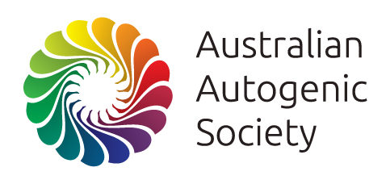
Helen is a Board Member and Head of the Oceania Chapter of the International Society of Autogenic Training and Psychotherapy, an Honorary Member of the British Autogenic Society, Founder and President of the Australian Autogenic Society and Full Member of the Australian Psychological Society. Her paper on Autogenics for OH&S in high risk industries was published in the recent edition of The European Journal of Autogenic and Bionomic Studies. She has a private practice in Sydney.
www.autogenicsociety.org

